
NAME : VAANI JINDAL
SAP : 500119144
BATCH : 2
SUBJECT : OOPS

EXPERIMENT -7

Abstract Classes and Interfaces:
- Write a Java program to create an abstract class Shape with an abstract method calculateArea(). Derive two classes Rectangle and Circle from Shape and override the calculateArea() method to calculate and print the area of a rectangle and a circle, respectively. Use the main() method to create objects of Rectangle and Circle and test their calculateArea() methods.
Code :
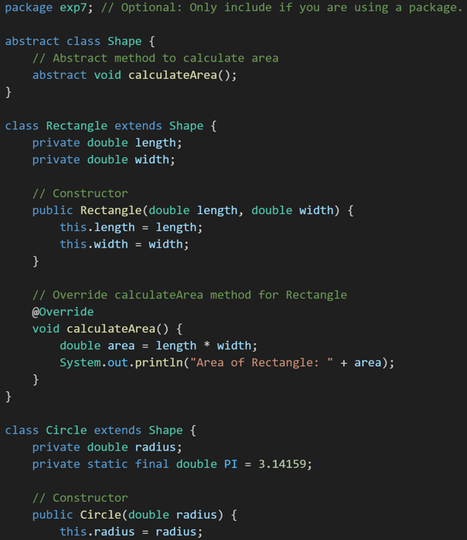

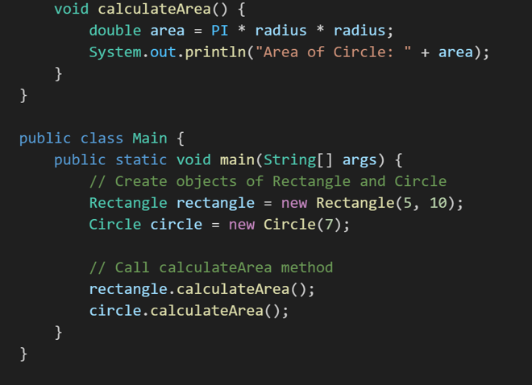

Output:
- Write a Java program to create an abstract class Employee with abstract methods calculateSalary() and displayDetails(). Derive two classes Manager and Developer from Employee and implement the methods to calculate the salary (e.g., based on fixed salary or hourly wage) and display employee details (e.g., name, role, salary). In the main() method, create objects of Manager and Developer and test their functionality.
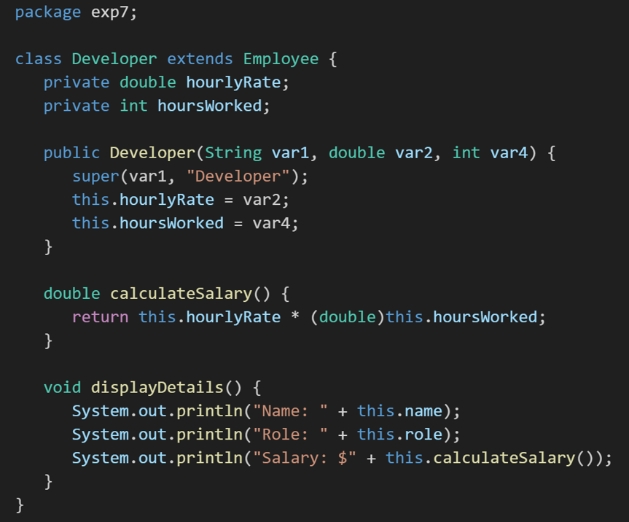
Code :

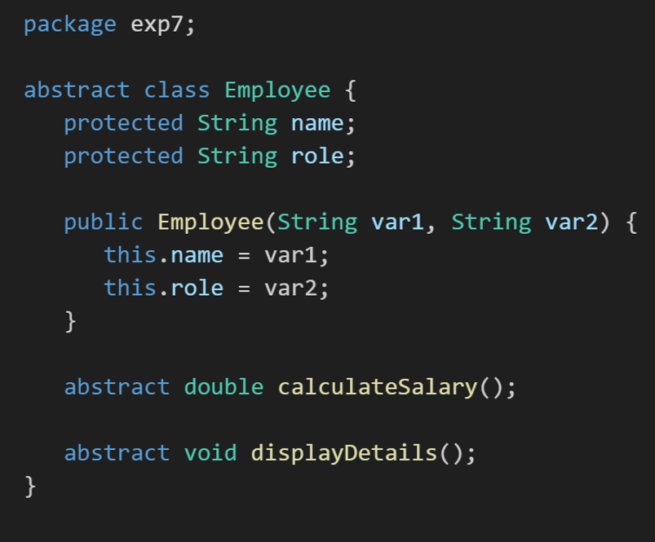
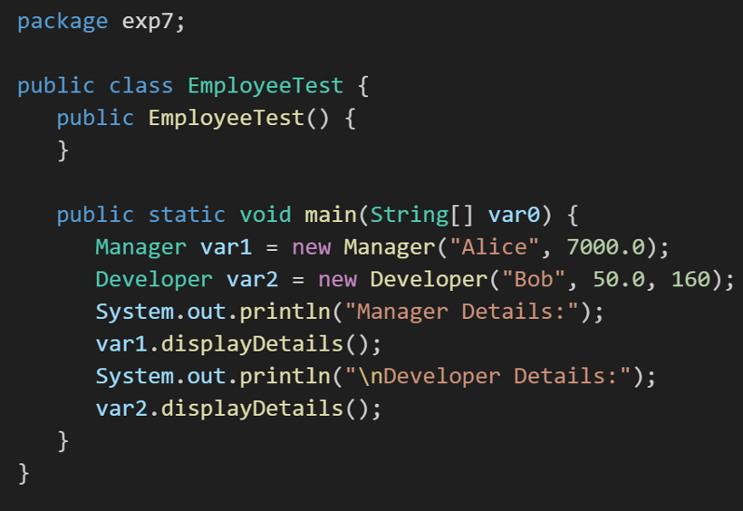
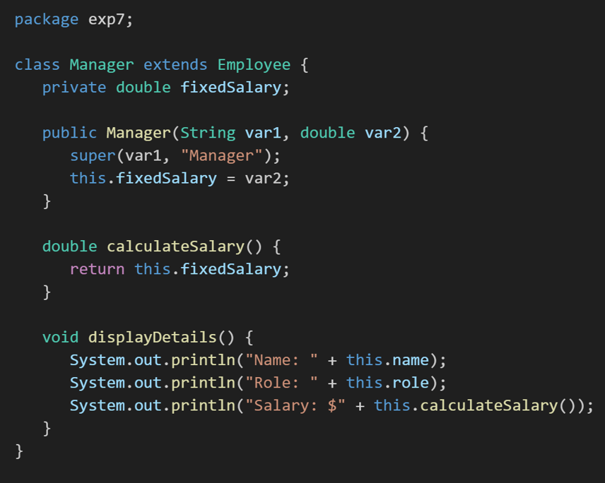
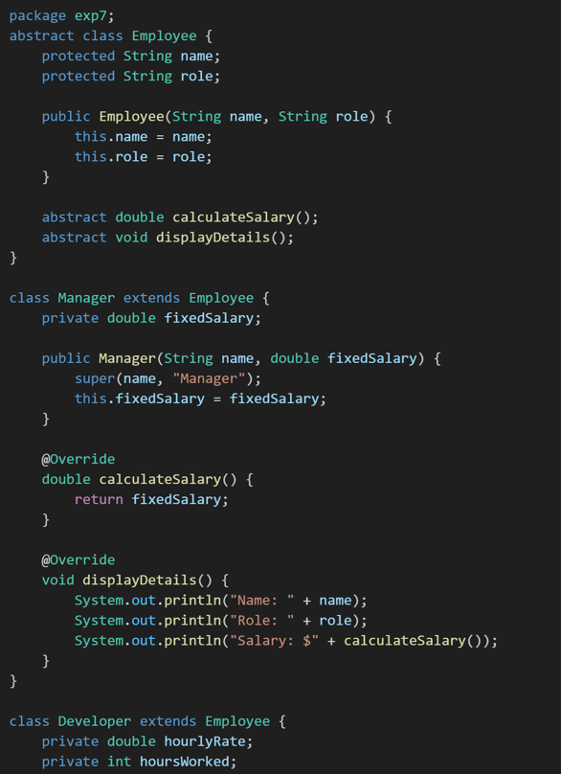
Output:
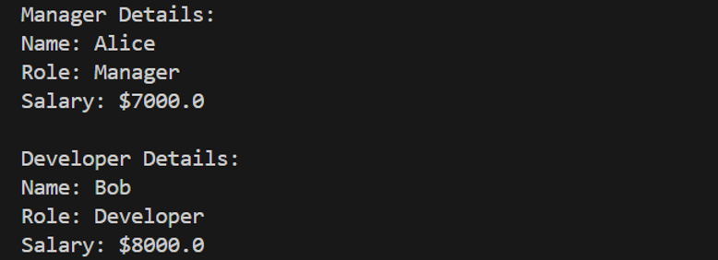
3. Write a Java program to create an interface Bank with methods deposit(double amount) and withdraw(double amount). Implement this interface in a class Account that overrides these methods to perform deposit and withdrawal operations on a balance variable. Create another class BankDemo with a main() method to test the functionality by depositing and withdrawing amounts and displaying the updated balance.
Code :
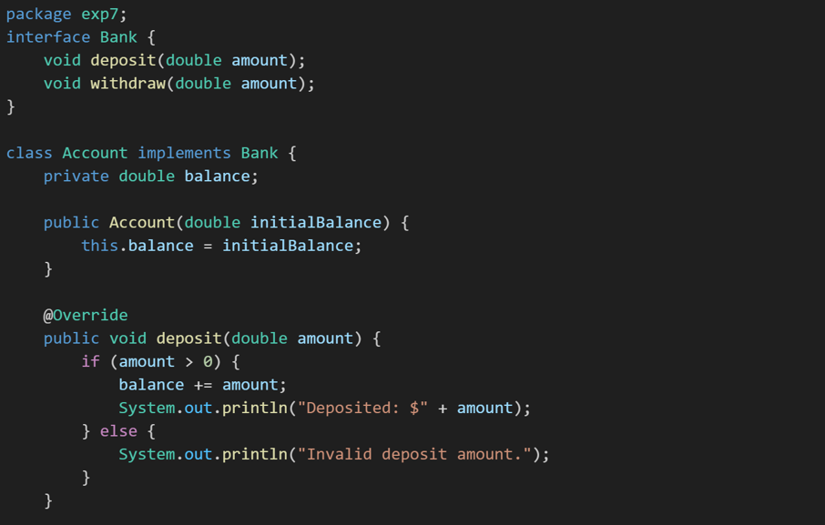
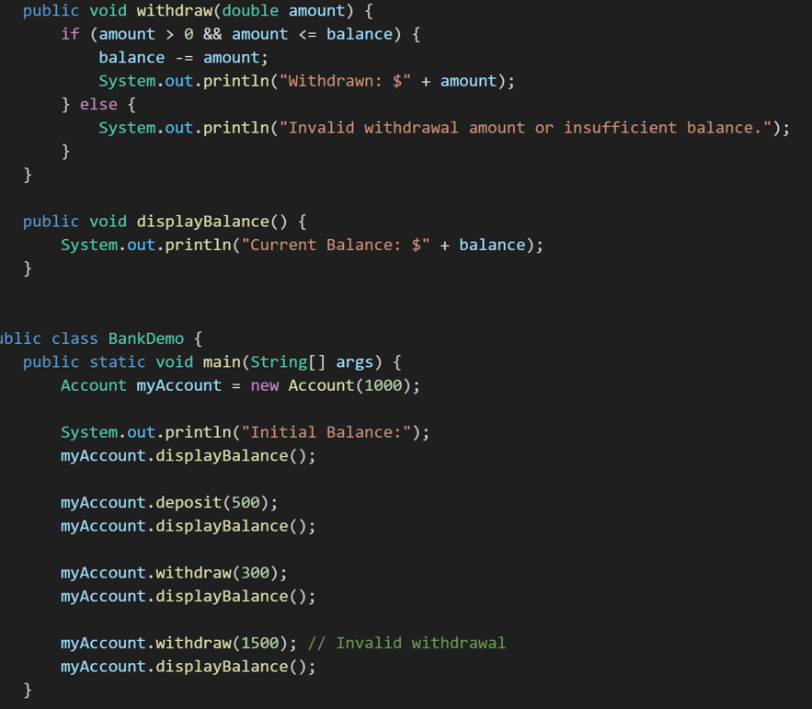
Output:
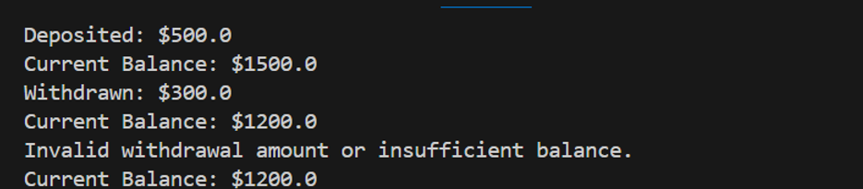
4. Write a Java program to create an interface Playable with methods play(), pause(), and stop(). Implement this interface in a class MusicPlayer that overrides these methods to print appropriate messages (e.g., "Music is playing," "Music is paused," "Music is stopped"). Create another class TestPlayer with a main() method to test the functionality by calling
the play(), pause(), and stop() methods.
Code:
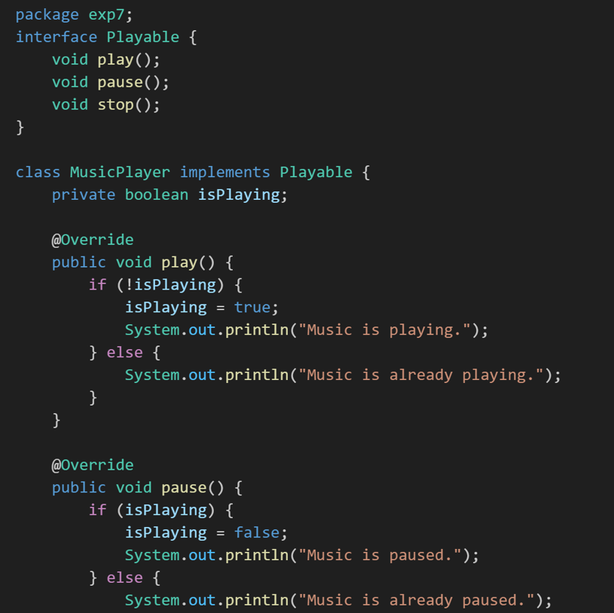
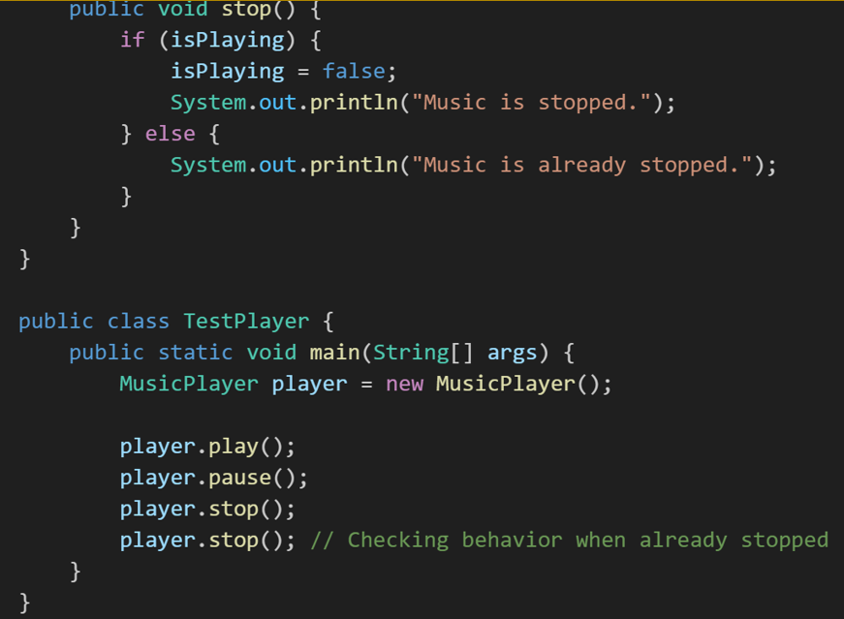
Output:
